**Practical No: 3**

**How to Create Host Pool for Application**

**Delivery**

**Agenda:**

Section 3: Implement Azure Virtual Desktop Host pool

1. Step by Step Implementation:
2. Create resource group
3. Create Virtual Network (internal)
4. Create a host pool
5. Create Azure virtual desktop (create a session host)
6. Assign an AD user
7. Add Role Assignment and Add members.
8. Configure Virtual Desktop host pool
9. Add virtual desktop workspaces
10. Create host pool Application Delivery
11. Log in to the Azure Virtual Desktop (Session Desktop).

Reference link: https://www.youtube.com/watch?v=9OTGdvM-V7c

1. **Step by Step Implementation to Add Session host Manually to Host pool:**
2. Creating a New Azure Resource Group:

* In the Azure portal, select 'Resource groups' from the left-hand menu, then select '+ Add resource group'.
* In the 'Create resource group' blade, enter a name for your resource group and select the 'Subscription', 'Resource group location', and 'Pricing tier' fields. Then, select 'Create'.

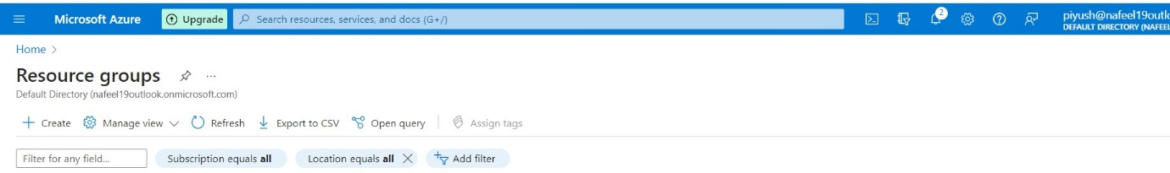

* 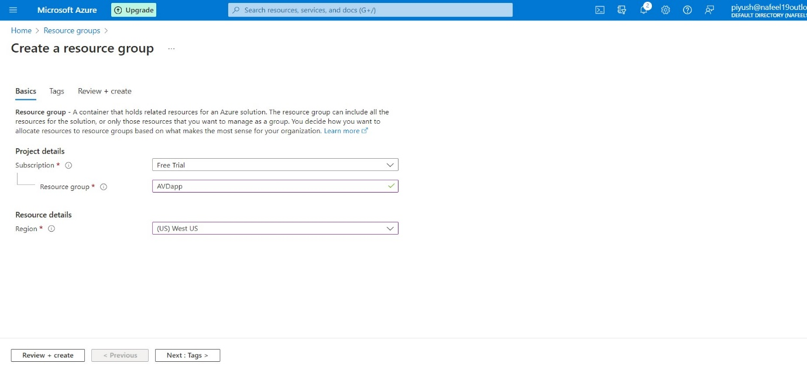In the 'Create resource group' blade, enter a name for your resource group and select the 'Subscription', 'Resource group location', and 'Pricing tier' fields. Then, select 'Create'.

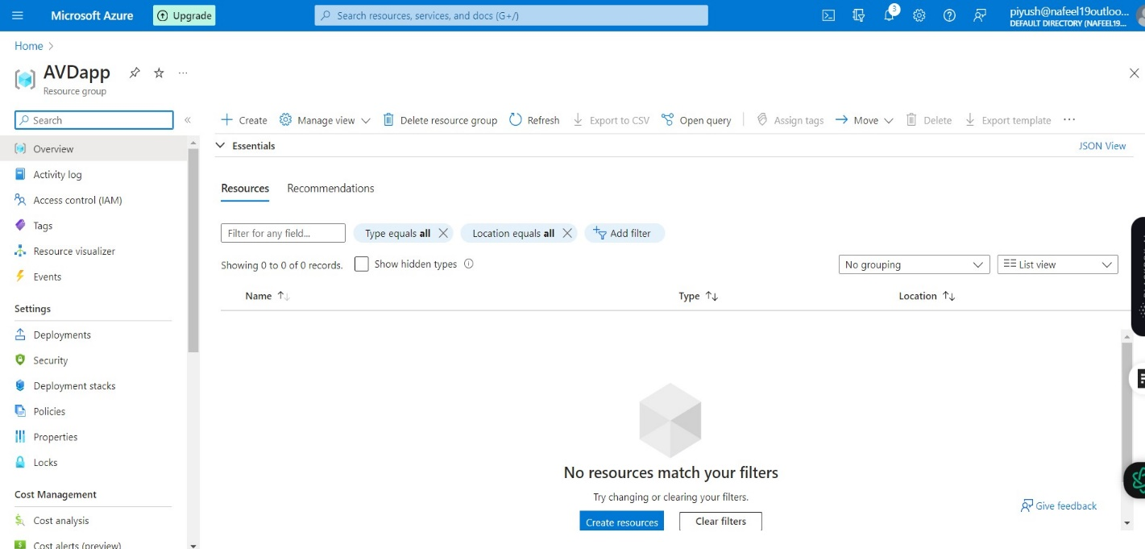

1. ***Create a virtual network:***

We need to create a virtual network for the machines we are going to use later on. To do this, perform the following steps:

* Open Azure Portal as an Administrator.
* Search for Virtual Networks.
* 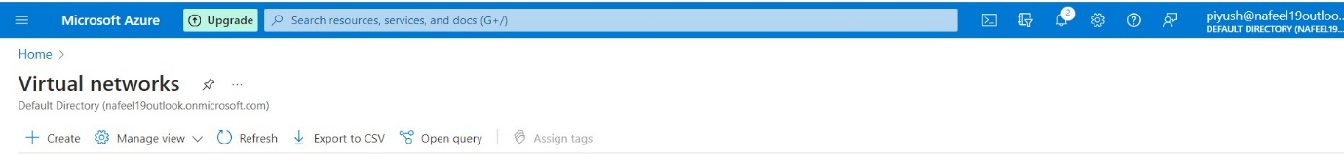Click on Create.
* Select your subscription type and add the existing created AVDapp resource group that will have access to the network.
* Give a name to the virtual network and select the region.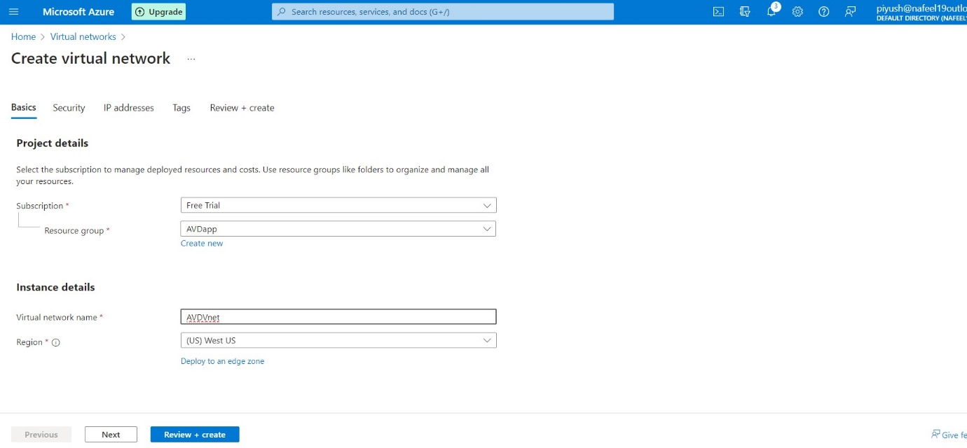
* 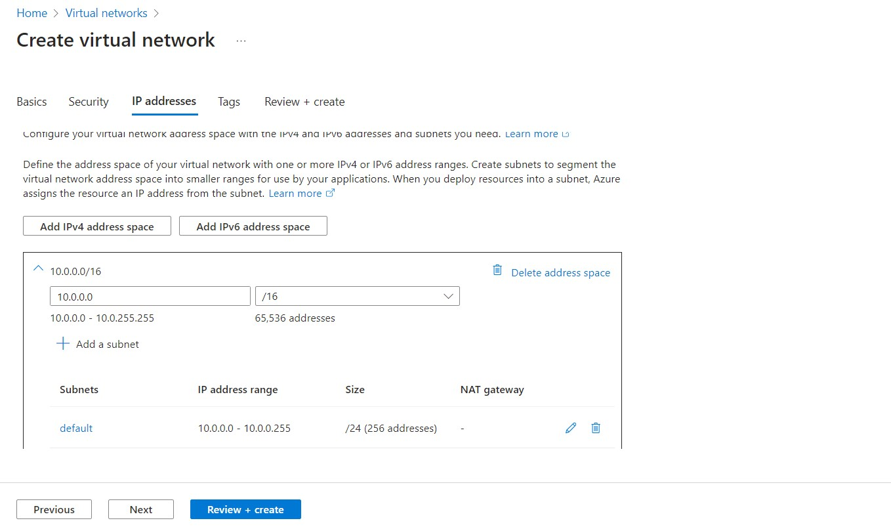In the IP Addresses tab, leave everything as default.
* 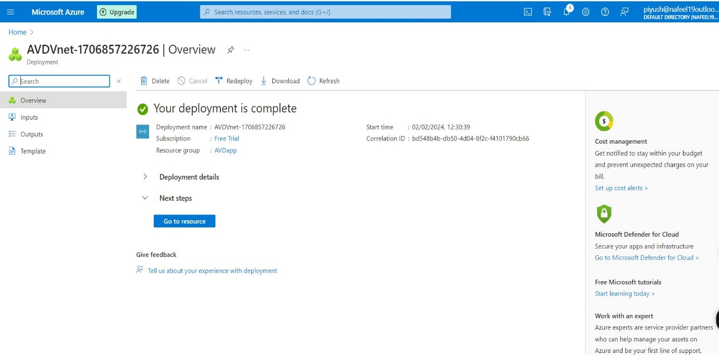Click to create virtual network

1. ***Create a host pool:***

After the virtual network is configured, we need to create a host pool for the virtual machines. To do this, perform the following steps:

* + In Azure Portal, search for Azure Virtual Desktop.
* 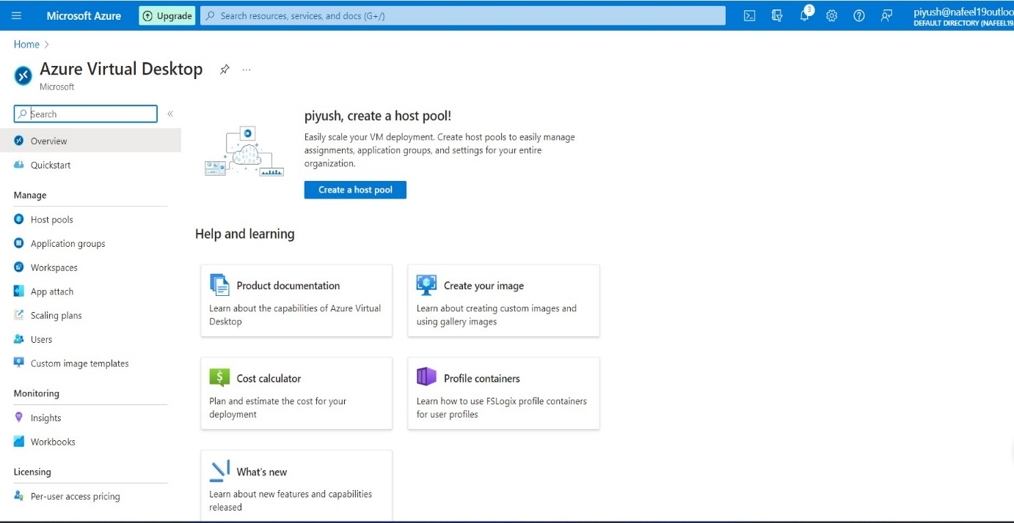Click on Create a host pool.
  + Select your subscription and choose the existing created resource group - AVDscale you previously added for the virtual network.
  + Add a host pool name and location West US, keep same location for all the process in AVD.
  + Under the host pool type, select pooled.
  + Under the Load balancing, select Breadth-first
  + Max session limit as per requirement.
  + 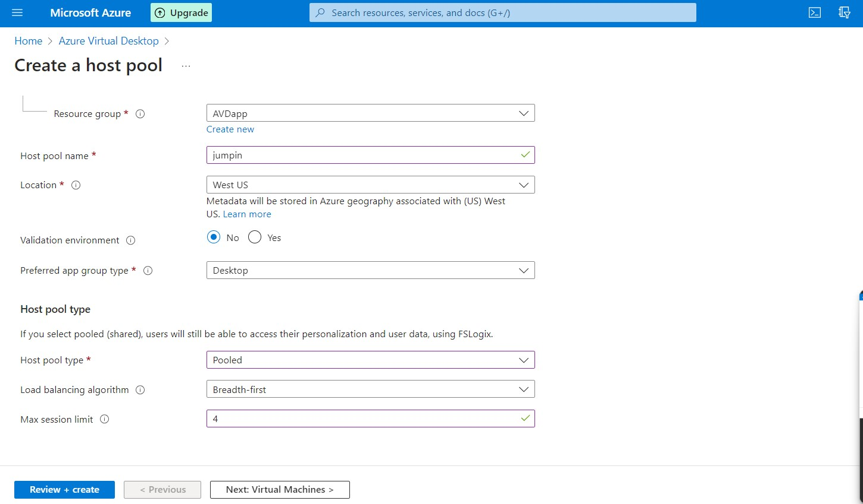Click Next.

1. ***Create Azure virtual desktop (create a session host):***
   * In the Virtual Machines tab, select Yes to add a virtual machine.
   * Add existing created Resource group AVDapp.
   * 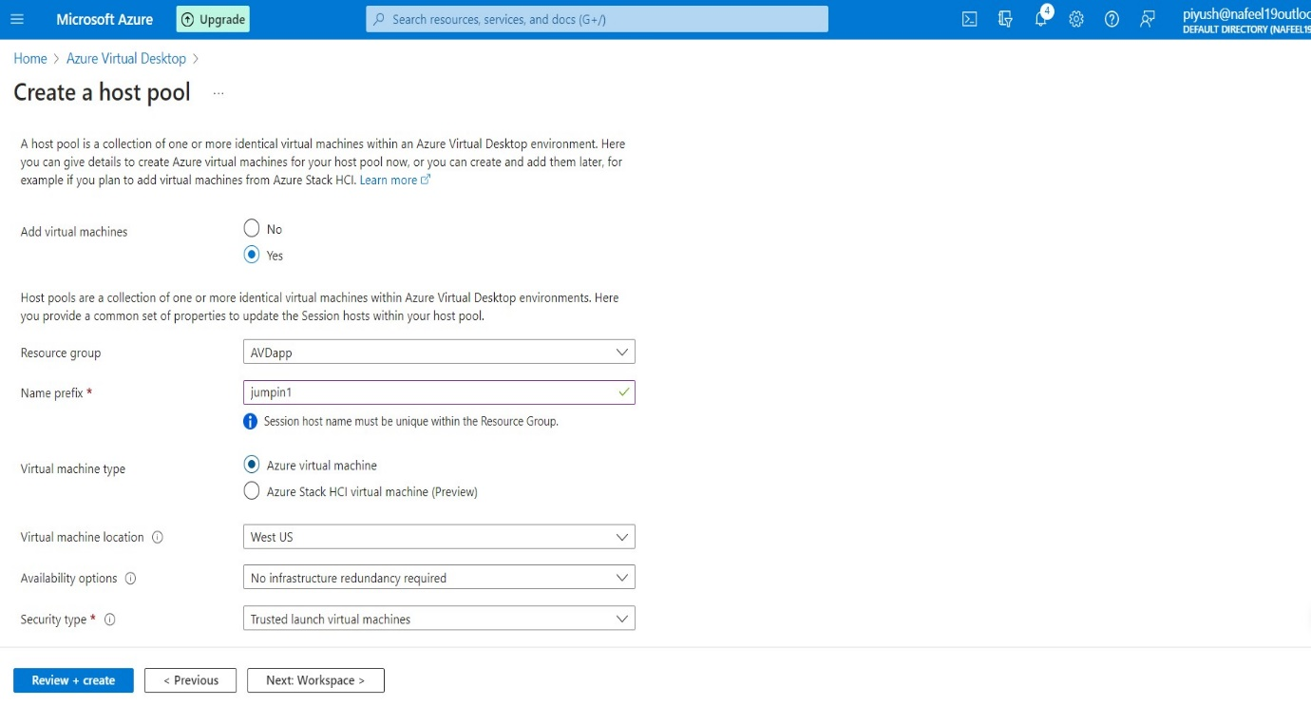Add a prefix name and location West US, keep same location for all the process in AVD.
   * 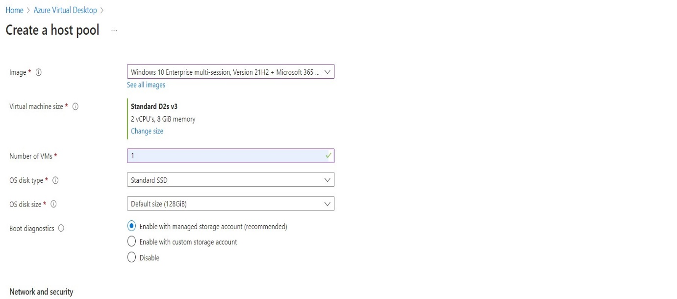You can add as many machines as you want in this step. We only added one and left everything else to standard.

* Under the Network and security, make sure to select the previously created Virtual Network. No other network configurations are necessary.

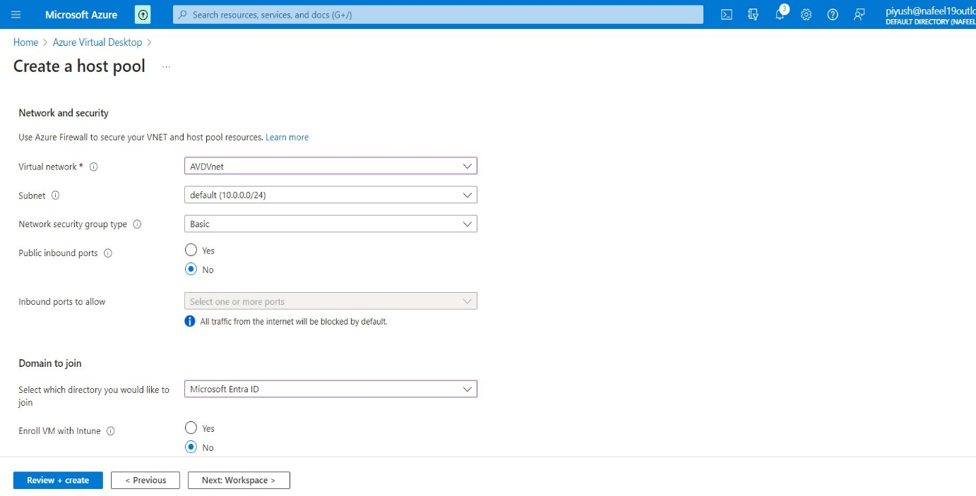

* Under Domain to join.
* In our case, we don’t have a separate AD site, so we chose to join with the Azure Active Directory. We also went with the option to not enrol the VM with Intune.
* As a last step in this tab, put user name and Password administrator account so you can access the VM.
* 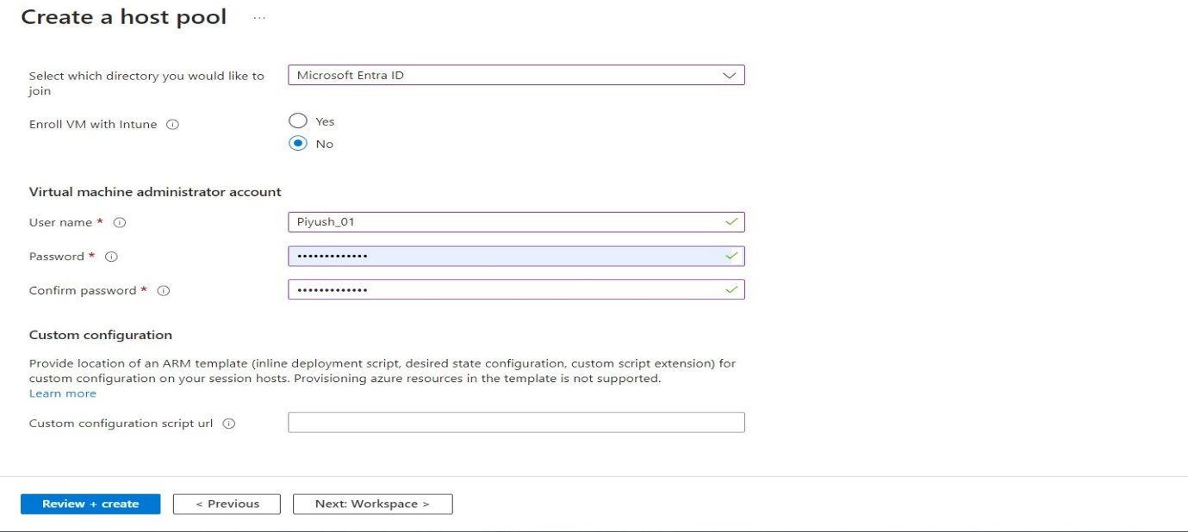Click Next.
* Click to Create AVD Host pool.
* 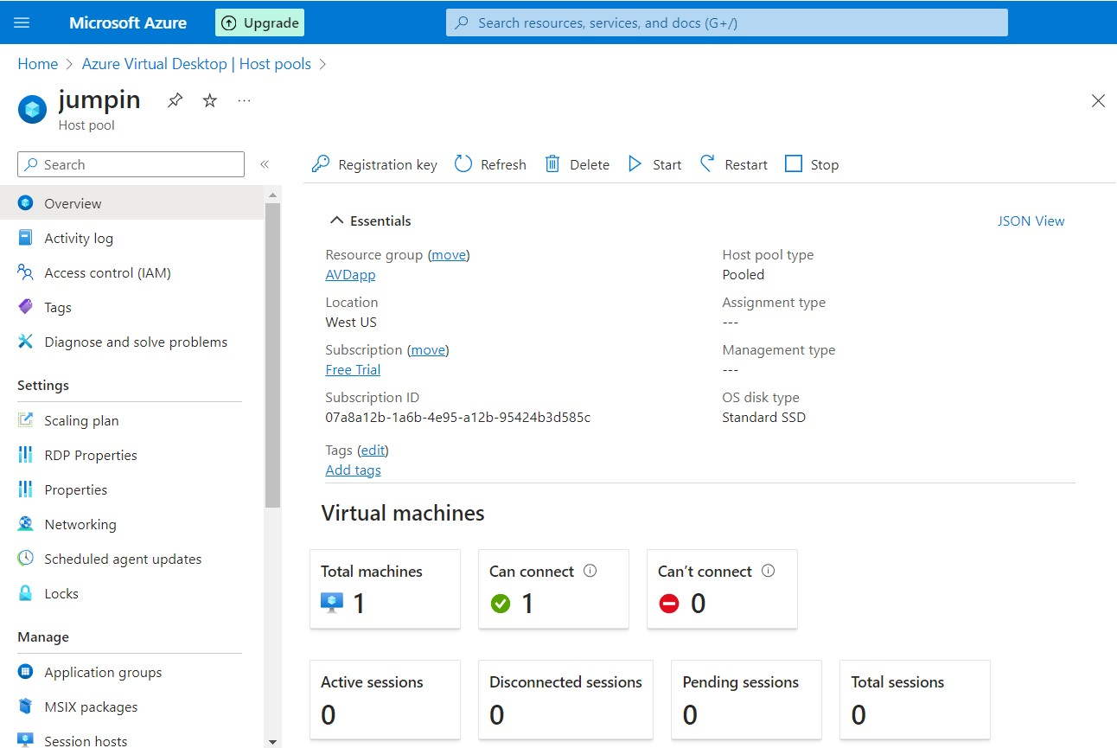Host pool is ready.

1. ***Assign an AD user:***

* 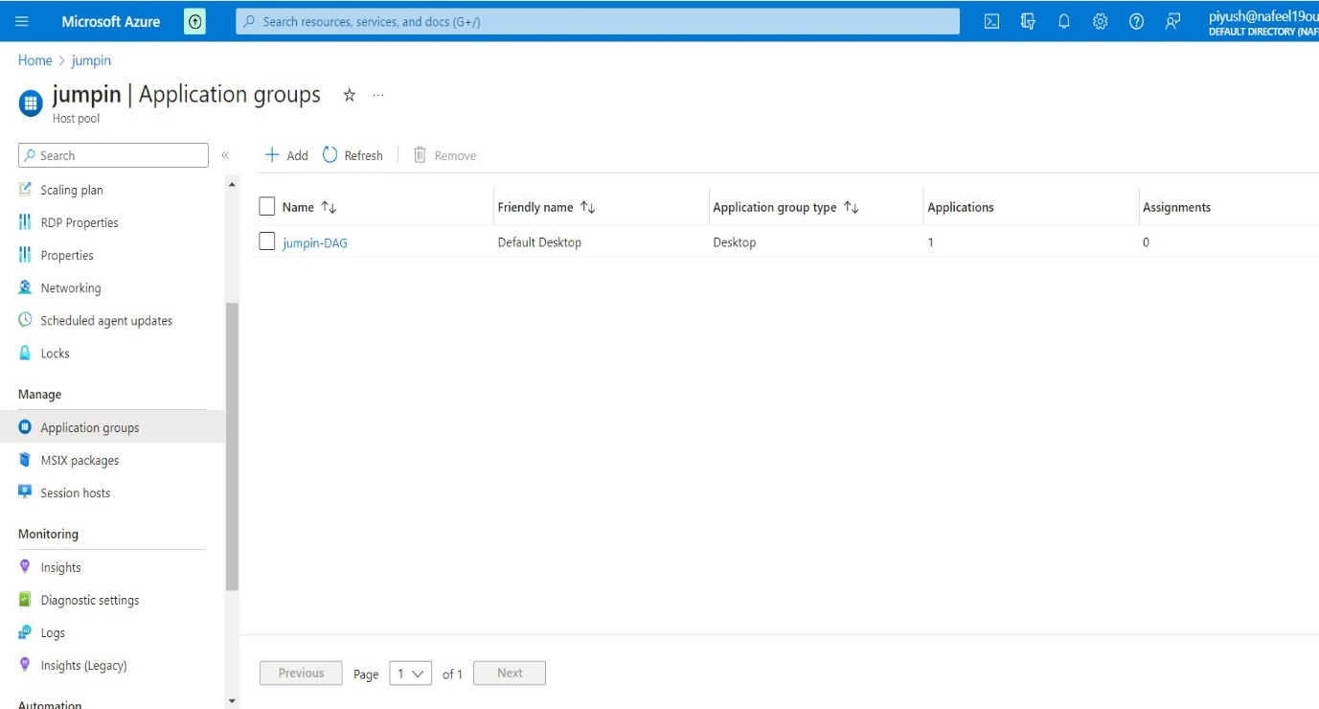In Manage → Application groups

**↑**

**Click on jumpin-DAG**

**←**

* In Application groups →Click on jumpin-DAG →In Manage →Assignments

**↑**

**Click to Add**

**←**

* 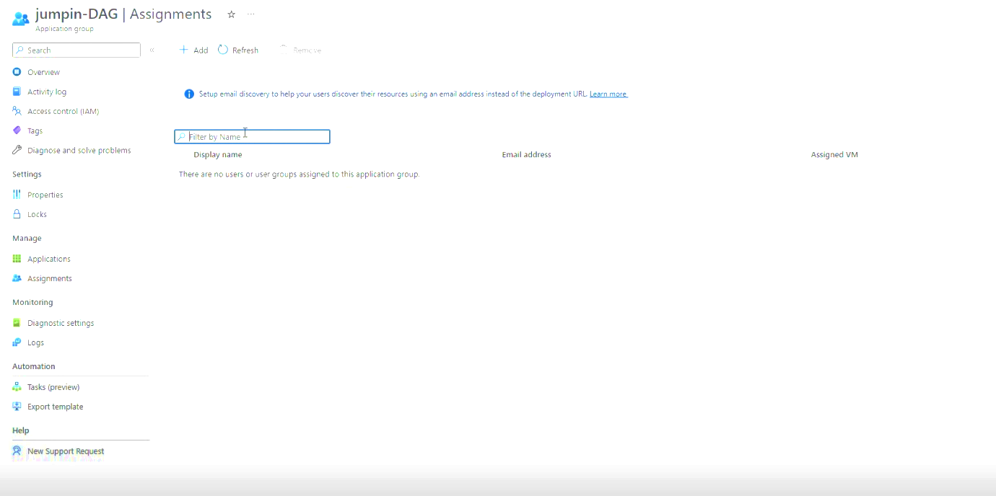Click to Add member to Access AVD.
* 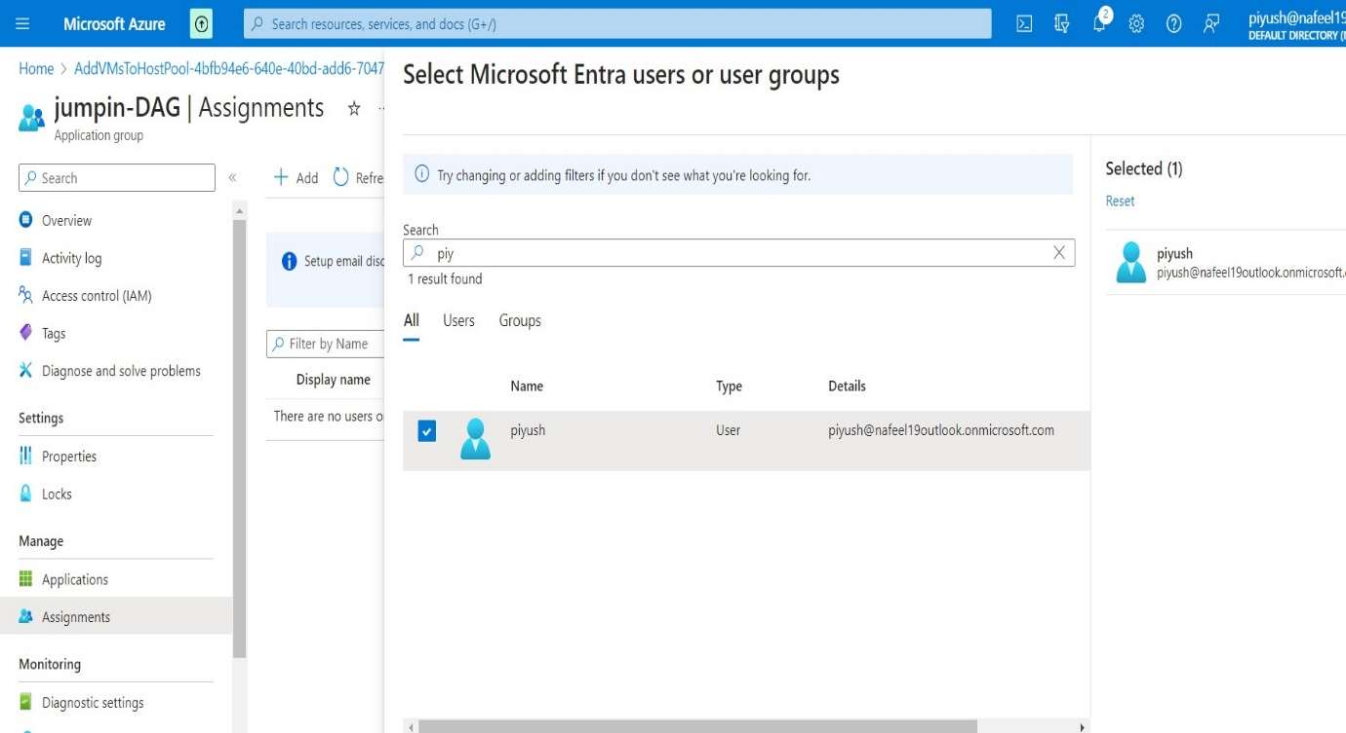Select Users as per requirements

1. **Add Role Assignment and Add members:**

* To Access AVD, required some Additional Access Role.
* In the Azure portal, select 'Resource groups' which we Created AVDapp.
* 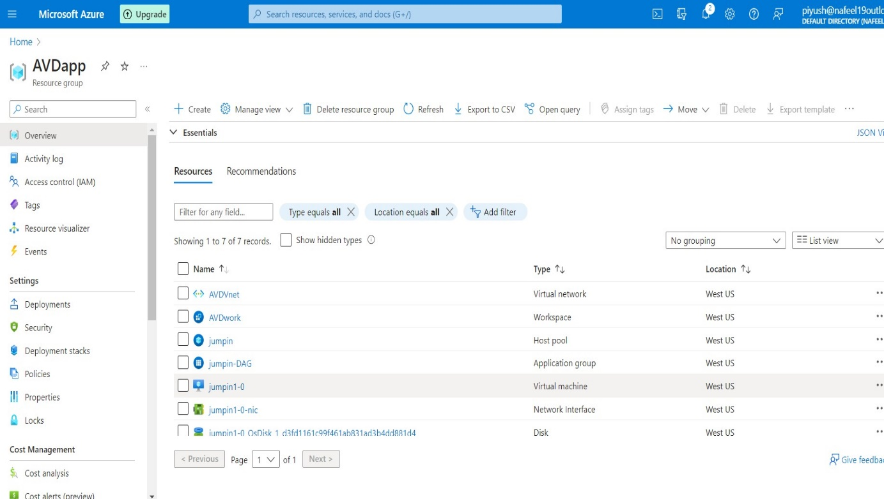Click on Access Control (IAM)

**←**

* 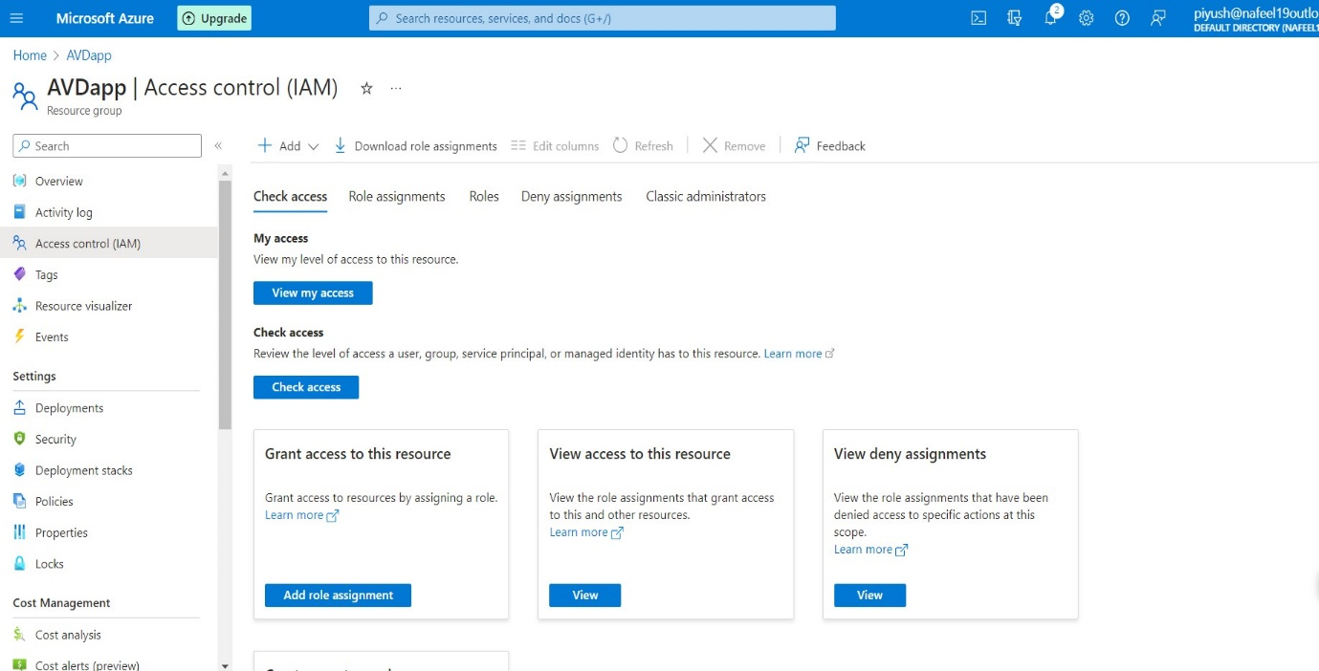Click to Add.

**↑**

* Click on Search → Virtual Machine User login →Select and Assign
* 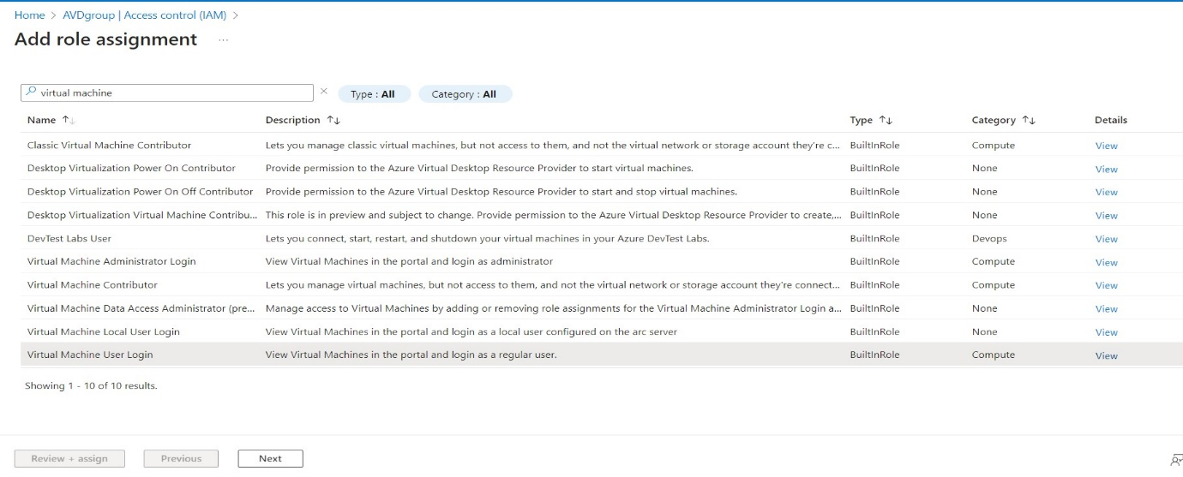Click to Next
* Click to Select members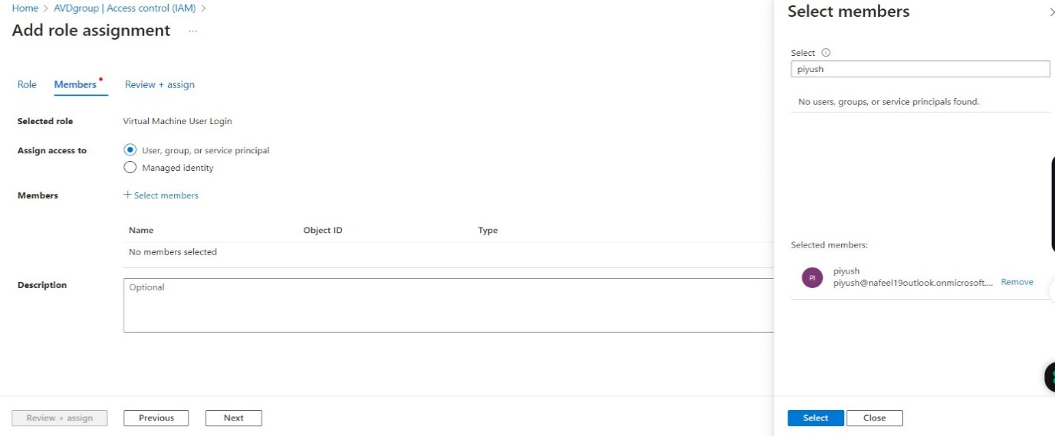

**← click on select**

* 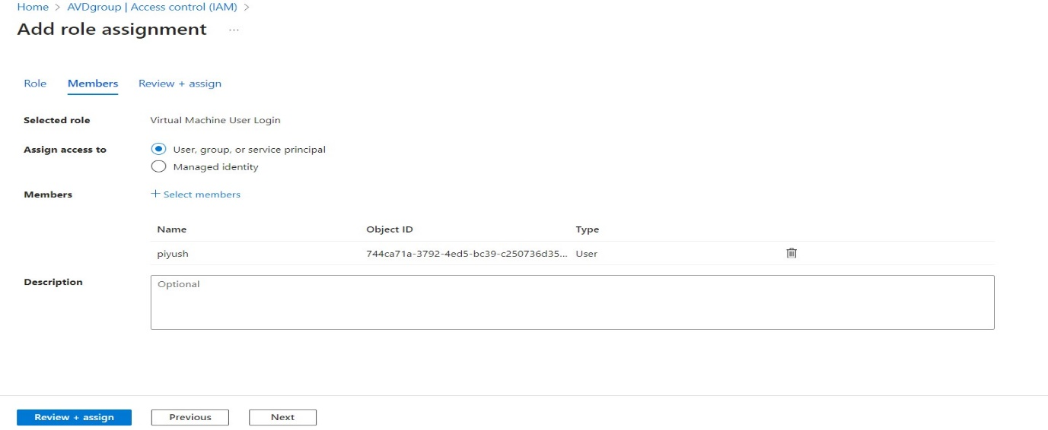Click to Assign
* Again, Same Step
* Click on Search → Virtual Machine Administrator Login → Select and Assign
* 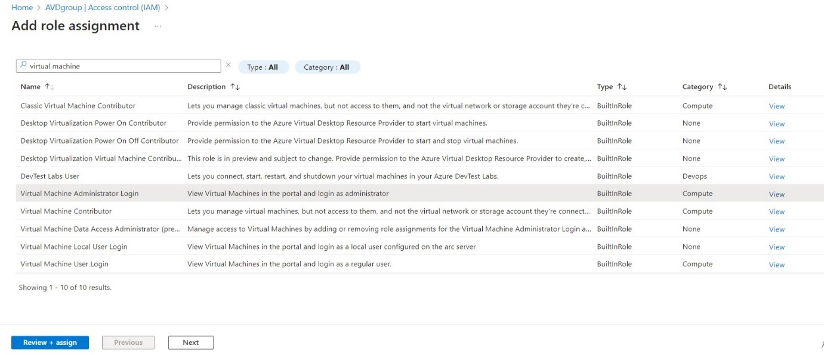Click to Next
* 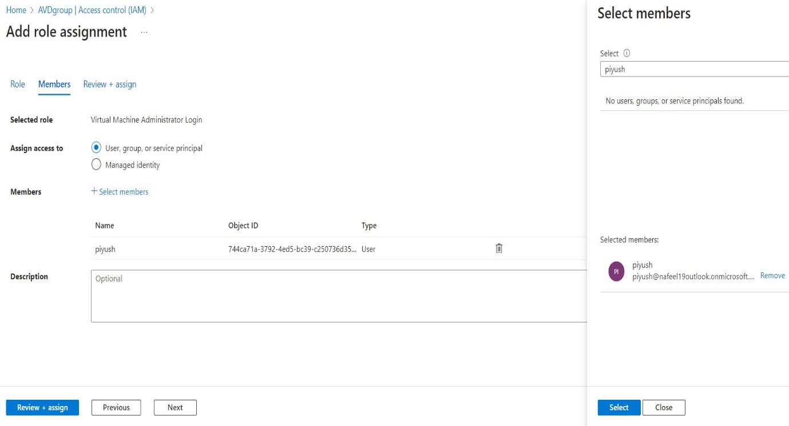Click to Select members And Assign

**← click on select**

**←**

**←**

**←**

1. ***Configure Virtual Desktop host pools:***

* In Azure Portal, search for Azure Virtual Desktop.
* Click on Host pool we Created jumpin
* In settings → Click RDP properties.

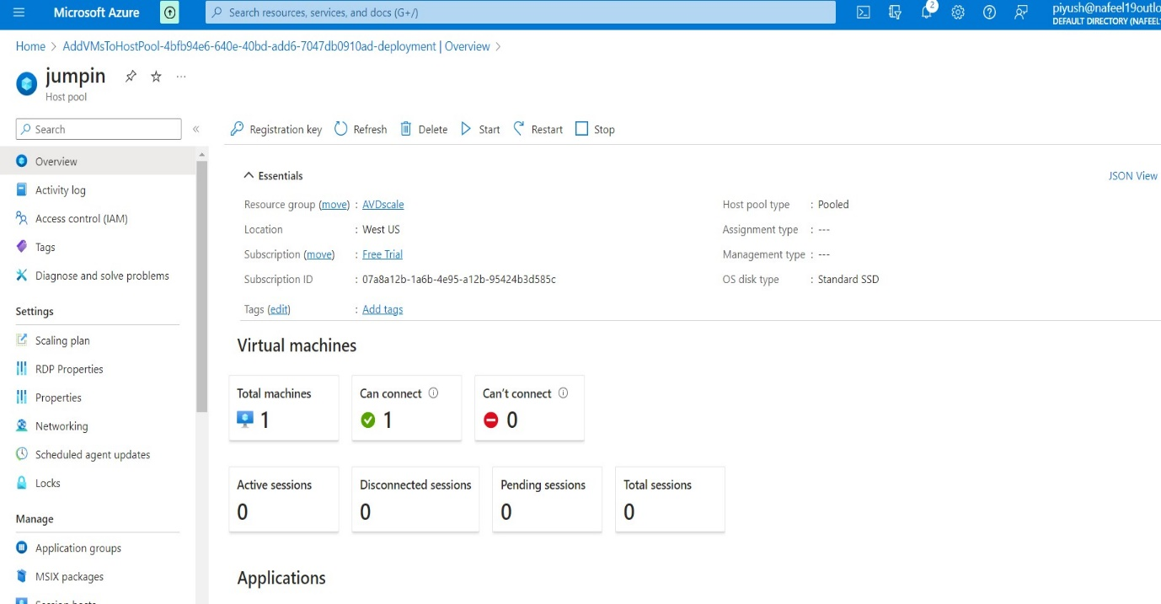

**←**

* Click on Advanced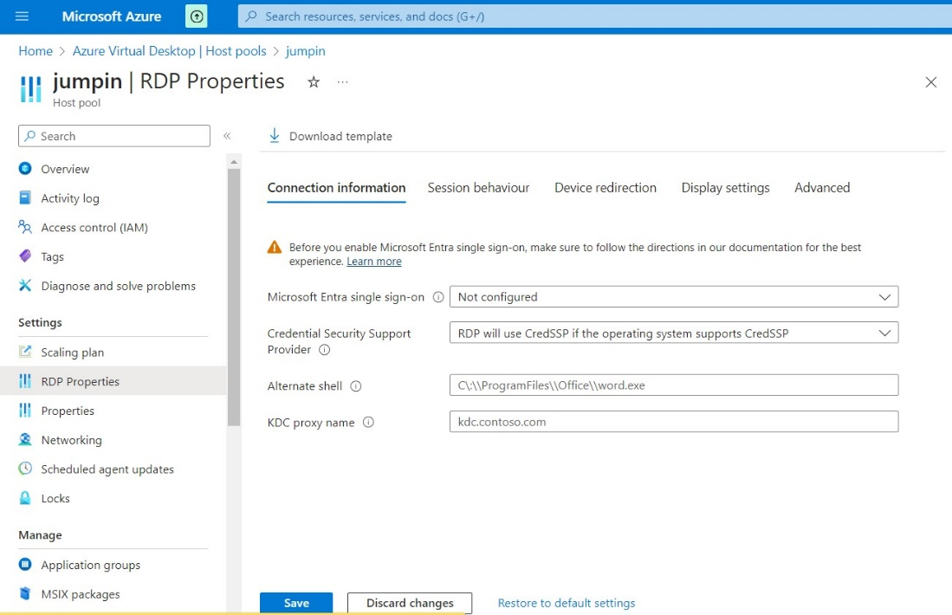

**↓Click on Advanced**

**↓Click on Advanced**

* In Advanced type this → **;targetisaadjoined:i:1**
* 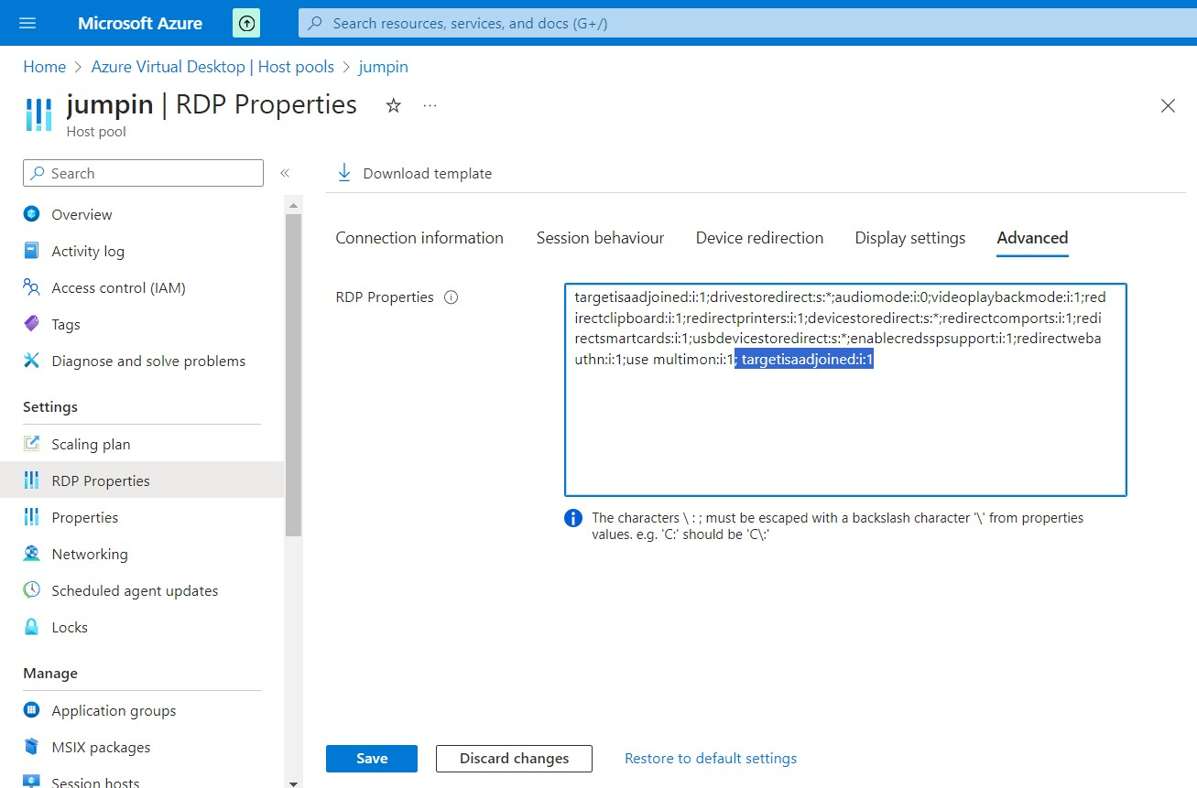Click to Save

1. ***Add virtual desktop workspaces:***

* In Azure Portal, search for Azure Virtual Desktop.
* Click on Create a host pool.
* In Mange → Click on Workspace.
* 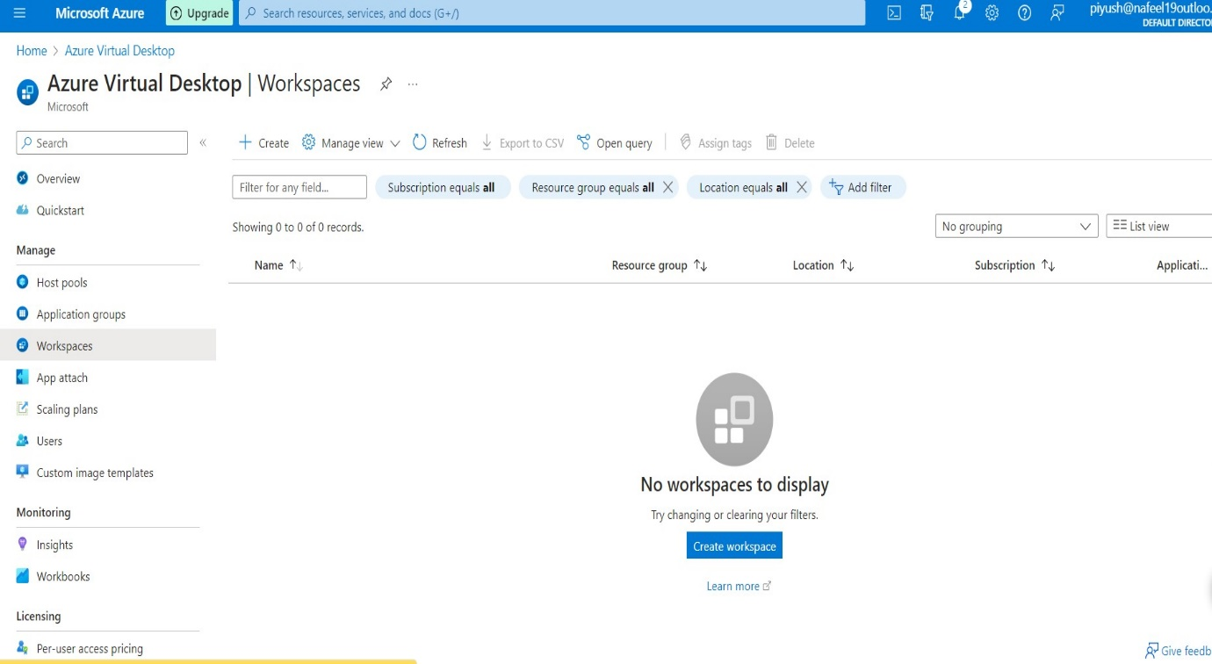Click to Create Workspace.

**↑**

**Click to Create**

* + 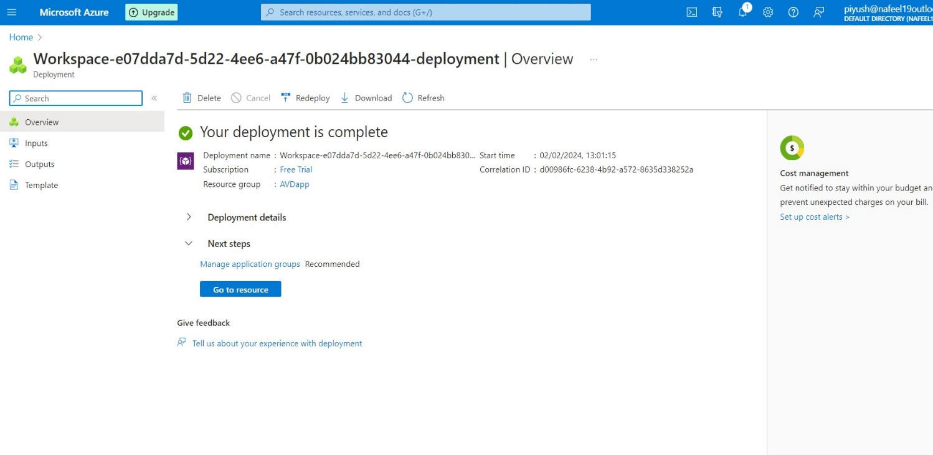Add existing created Resource group AVDapp.
  + Add a Workspace name and location West US, keep same location for all the process in AVD.

1. ***Create Host Pool for Application Delivery***

* Now Go to Azure Portal
* Search Azure Virtual Desktop
* Go to Application group
* Create new Application group to add Application to AVD

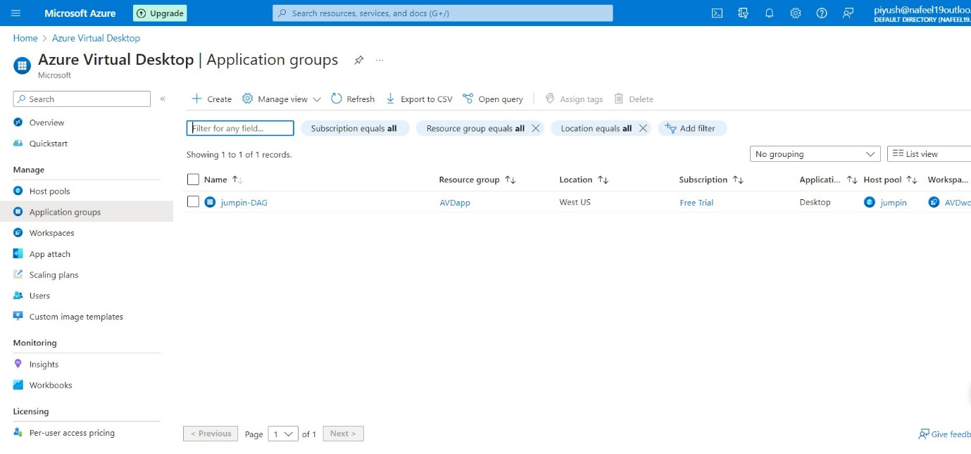

**↑**

**Click to Create**

* + Add existing created Resource group AVDapp.
  + ADD existing Host pool
  + Application group type = remoteapp
  + 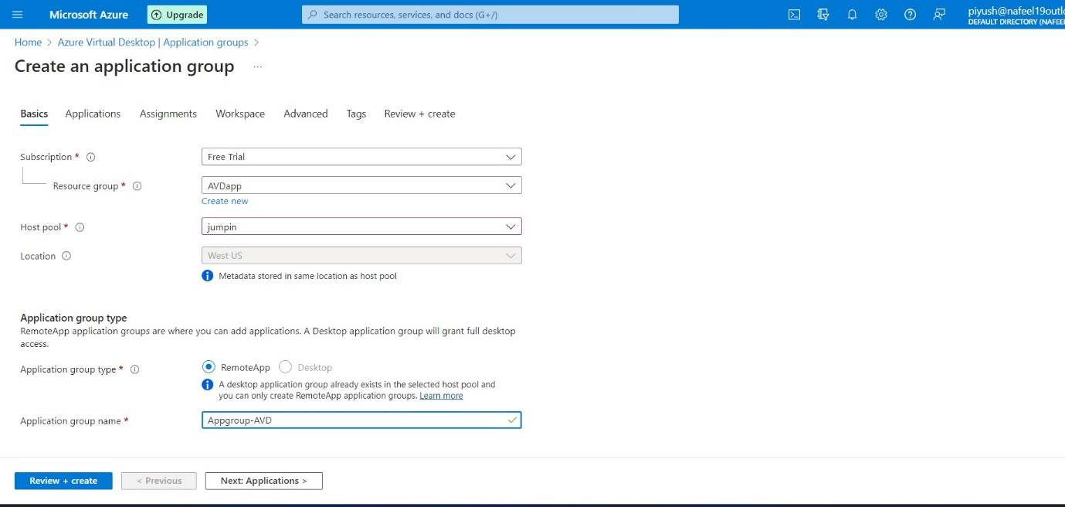Application group name as per required
  + 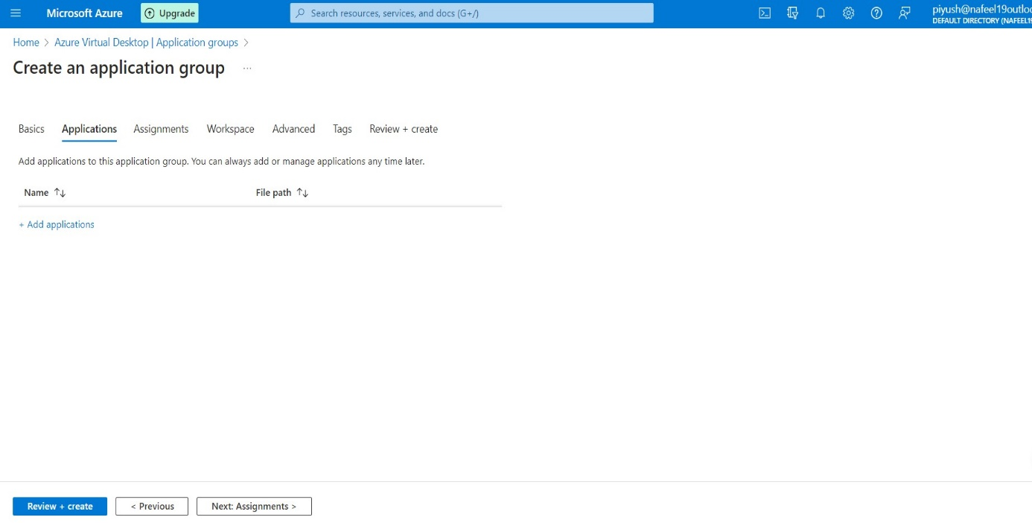Click to Add Application
  + Application Source= file path
  + Select path for any application for your laptop.
  + 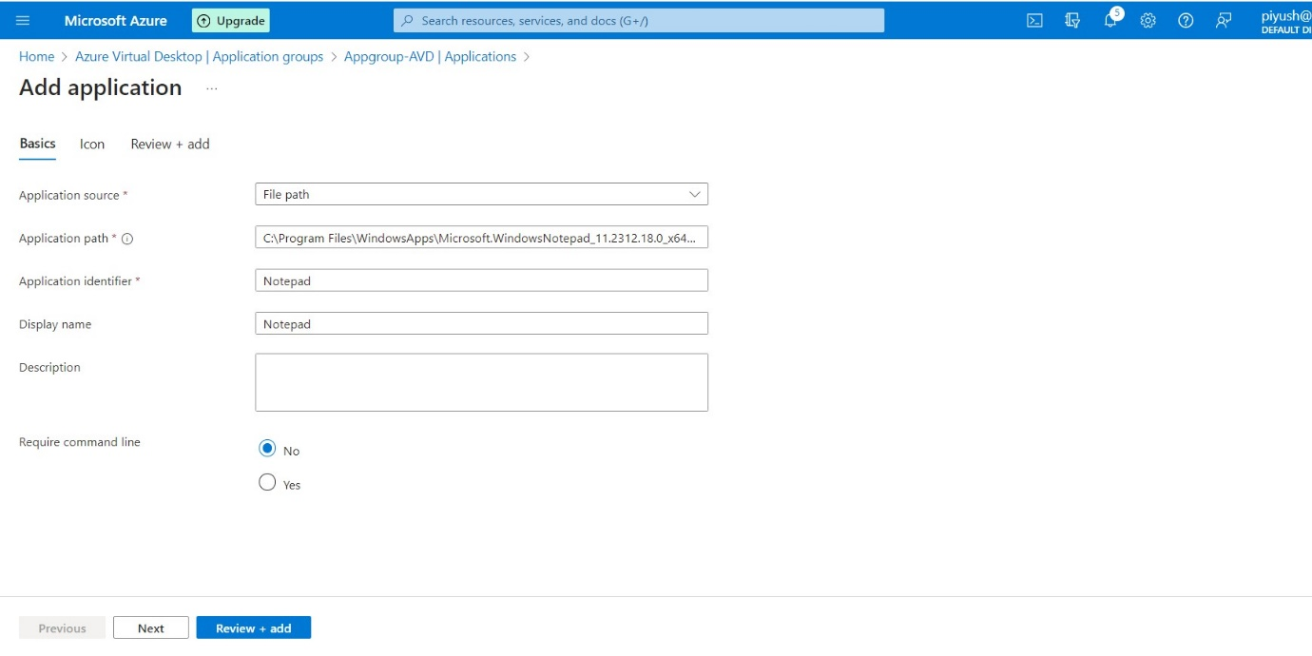Display Name = Notepad
  + past the path again to notepad in Icon path
  + 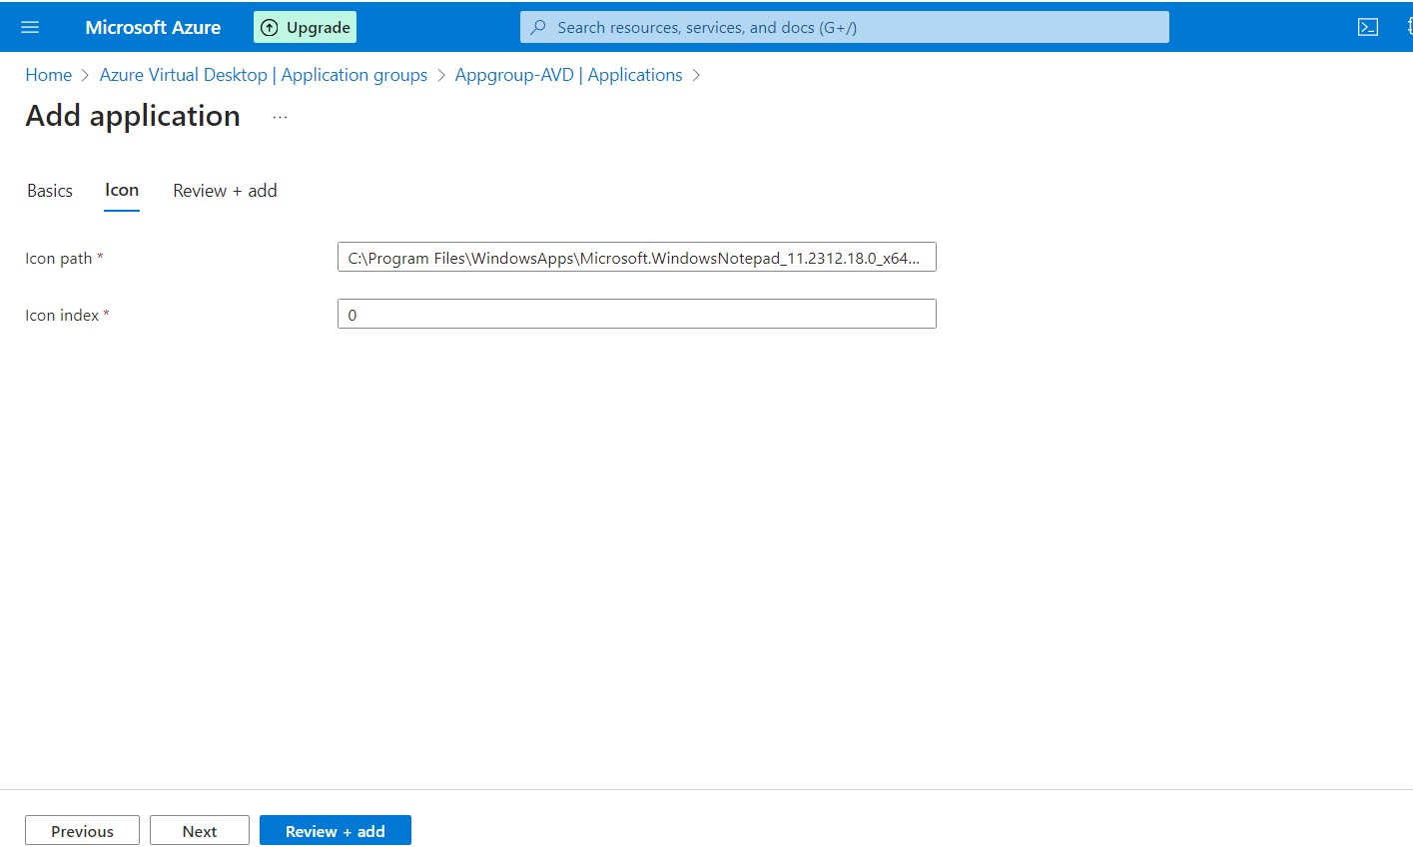click to add
  + 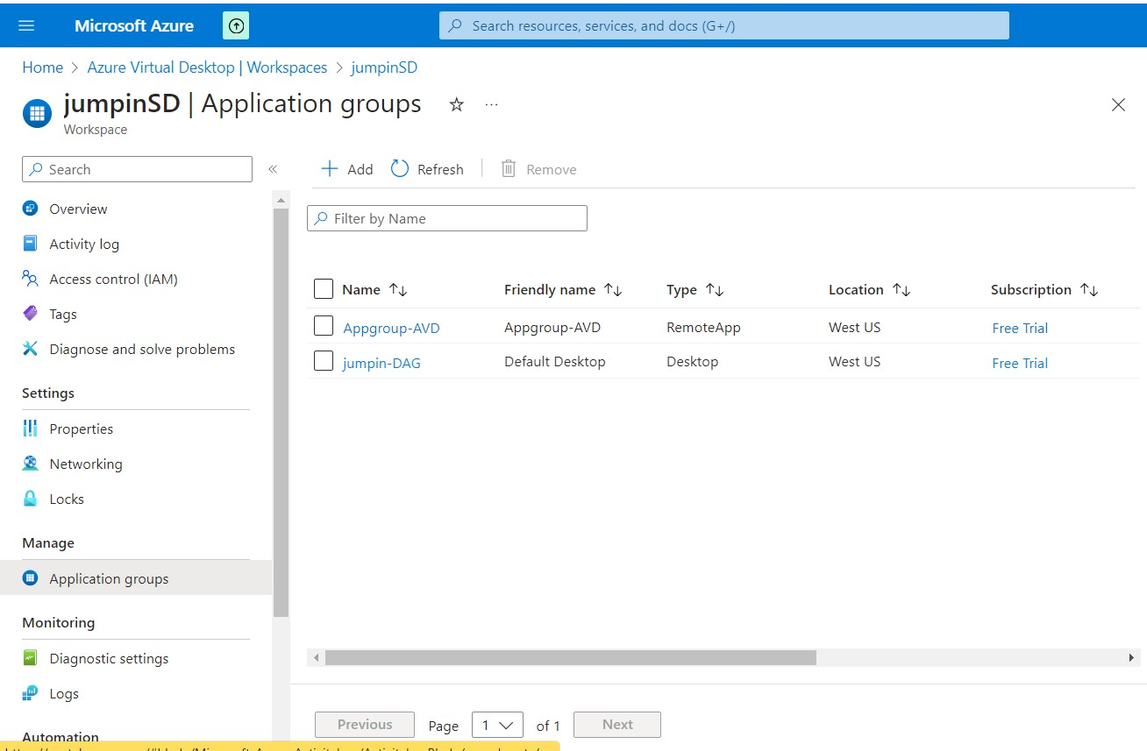Now our notepad Application is added.
* In Azure Portal, search for Azure Virtual Desktop.
* Click on Create a host pool.
* In Mange → Click on Workspace.
* 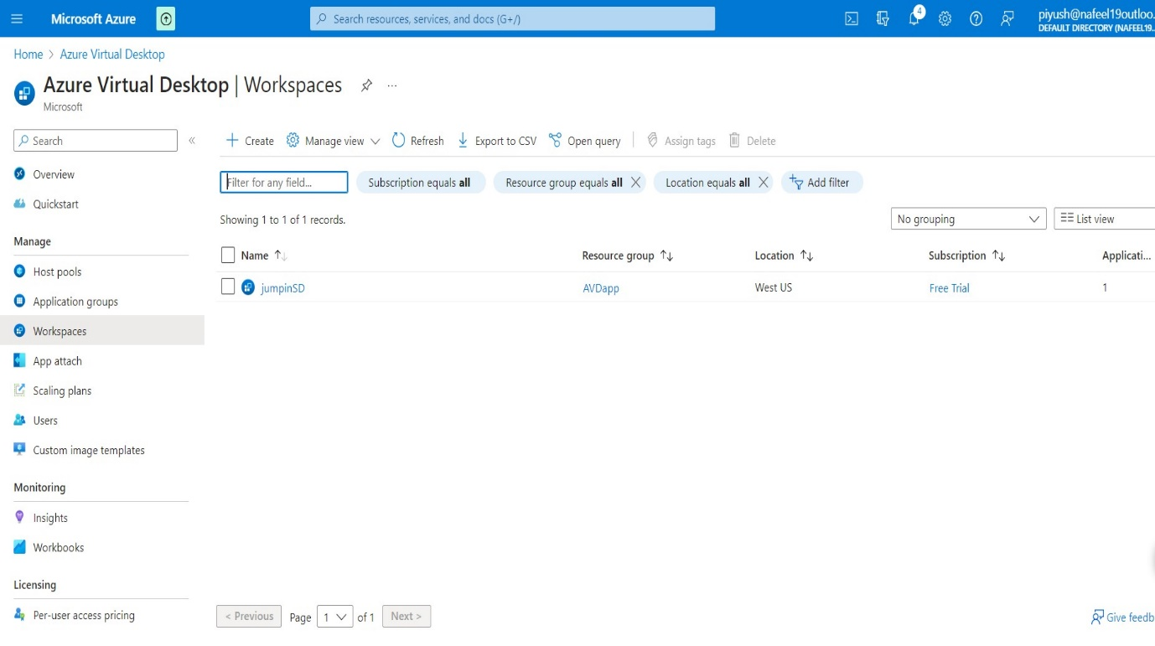we can see , we have create workspace

**↑**

**Click to Create workspace**

* Now Click to Application groups
* 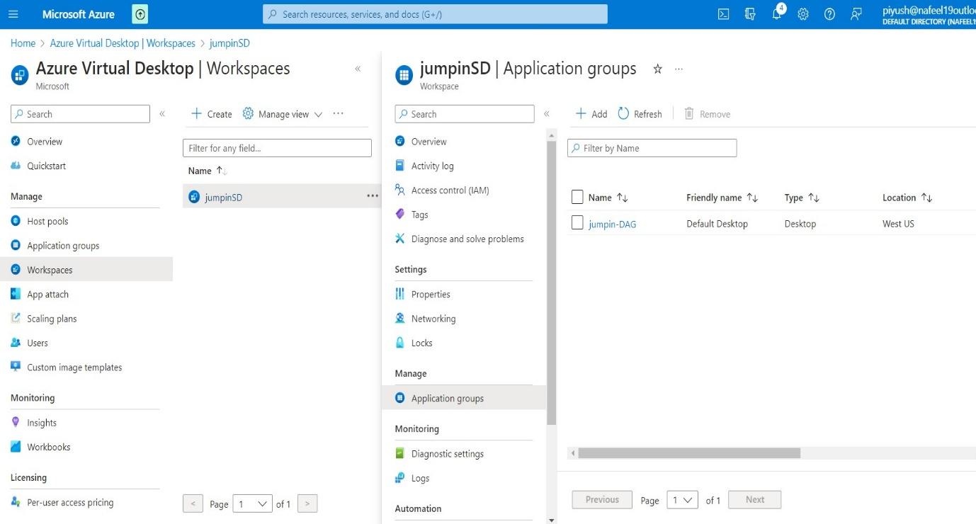Click to Add

**↑**

**Click to Add**

* Add both jumpin-DAG and
* 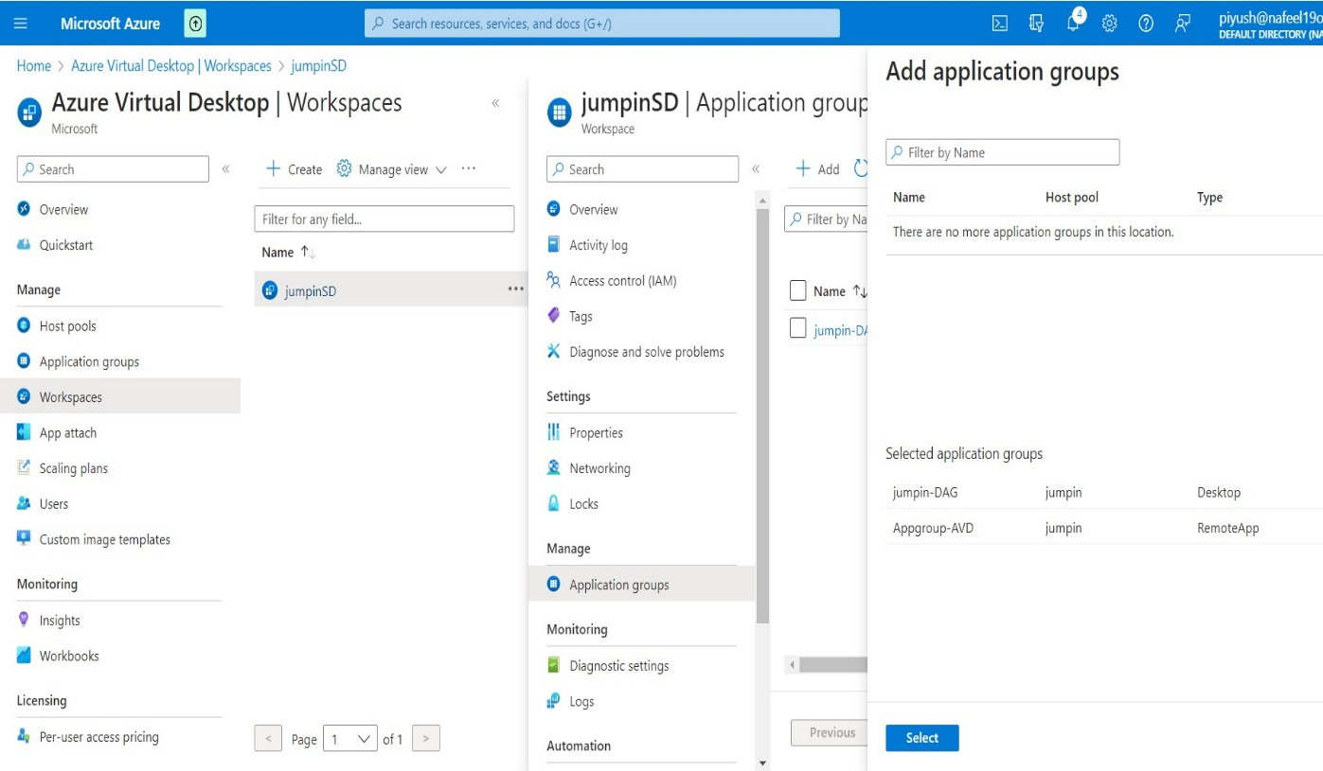Appgroup-AVD
* 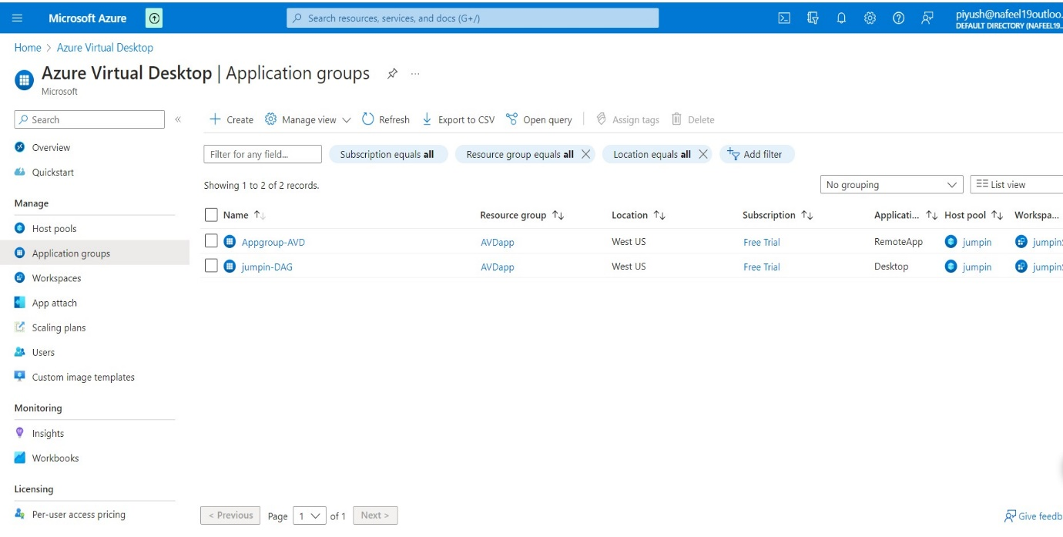Application groups is added

1. ***Log in to the Azure Virtual Desktop:***
   * After configuring your AVD host pool, you're ready to login to the Azure Virtual Desktop.
   * You can use the following link:

<https://rdweb.wvd.microsoft.com/arm/webclient/index.html>

* Copy this link and past in new tab
* 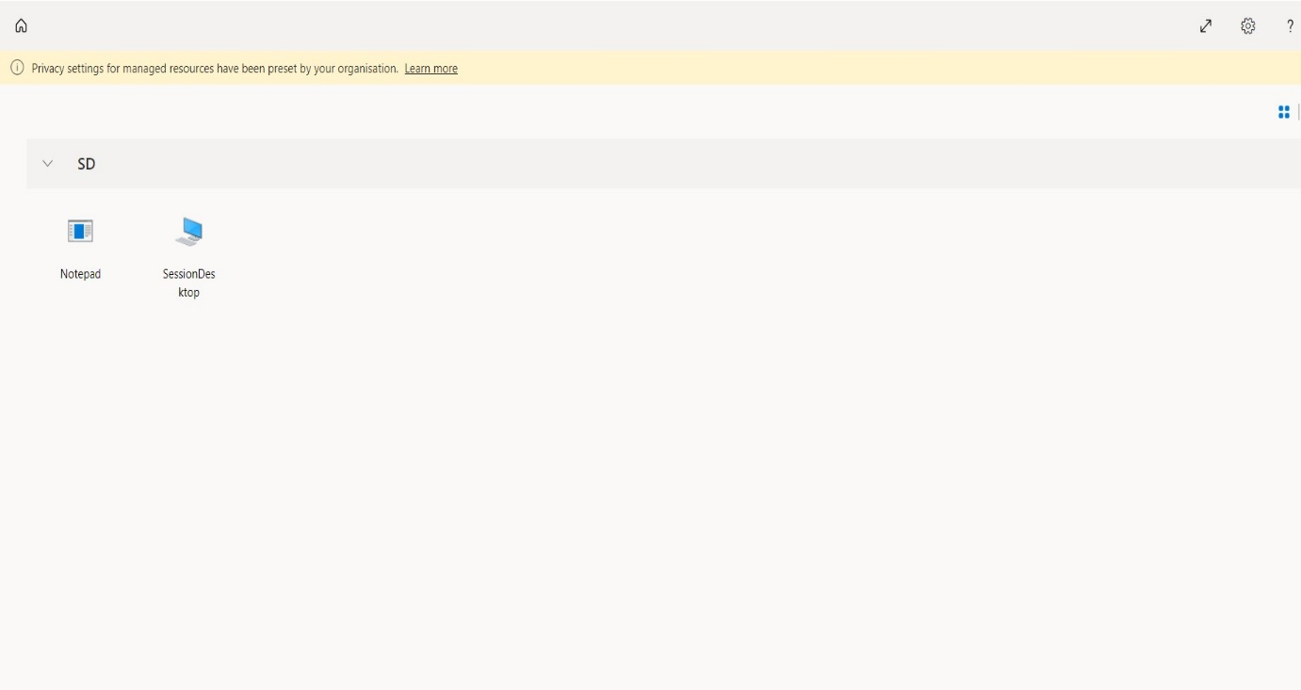Click on Session

**↑click on Notepad**

* Enter Username As per Selected AD User and Assign Role
* 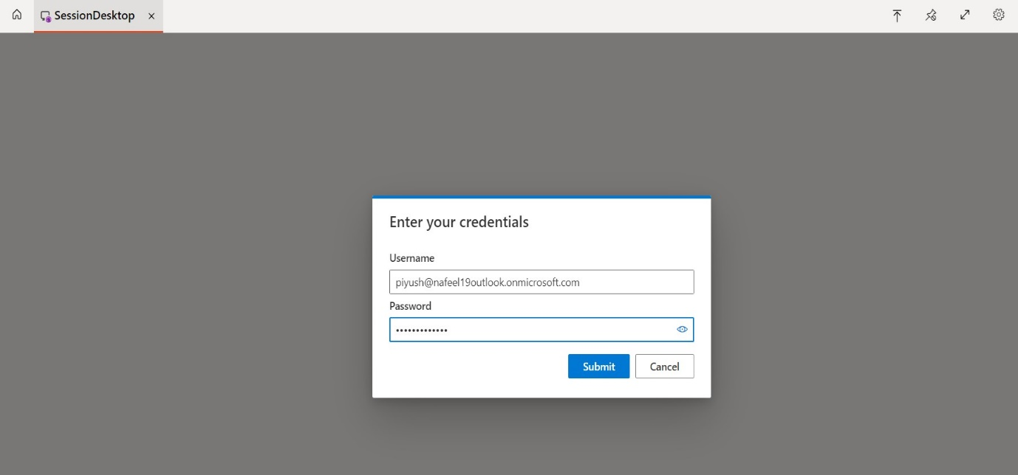Enter Password and Click to Submit.
* 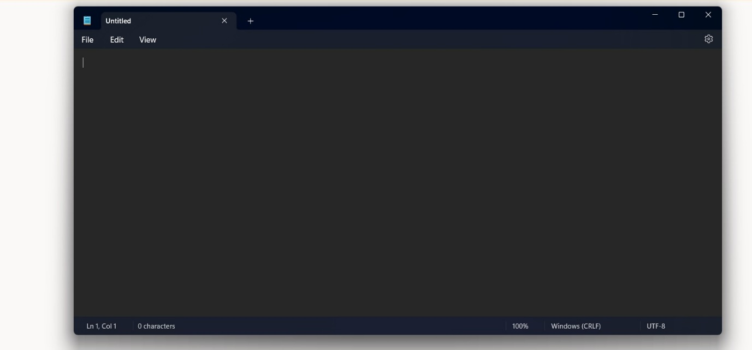 Now we can see, we can Access Notepad Application in AVD